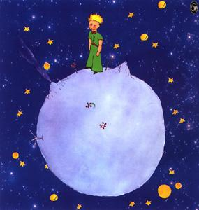

24 | 18 | 12 | 6
48 | 42 | 36 | 30
72 | 66 | 60 | 54

