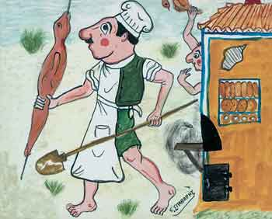

36 | 27 | 18 | 9
72 | 63 | 54 | 45
108 | 99 | 90 | 81

