ΣΤΑΥΡΟΛΕΞΟ
¹ |  |  |  |  |  |  |  |  | ²
 |  |  |  |  |  |  | ³
 |  |  |  | ⁴
⁵ |  |  |  |  |  |  |  |  | ⁶
 |  |  |  | ⁷ |  |  | ⁸

ΟΡΙΖΟΝΤΙΑ ΚΑΘΕΤΑ




1. 2.



3. 4.
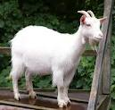
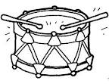
5. 8.

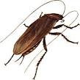
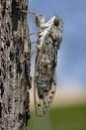
6.

7.

