The First Noel
The First Noel the angel did say
Was to certain poor shepherds
in fields as they lay;
In fields as they lay, keeping their sheep,
On a cold winter's night that was so deep.
Noel, Noel, Noel, Noel,
Born is the King of Israel.
They looked up and saw a star
Shining in the east beyond them far,
And to the earth it gave great light,
And so it continued both day and night.
And by the light of that same star
Three wise men came from country far;
To seek for a king was their intent,
And to follow the star wherever it went.
This star drew nigh to the northwest,
O'er Bethlehem it took it rest,
And there it did both stop and stay
Right over the place where Jesus lay.

Santa Claus is Coming to Town
You better watch out
You better not cry
Better not pout
I'm telling you why
Santa Claus is coming to town
He's making a list
And checking it twice
Gonna find out Who's naughty and nice
Santa Claus is coming to town
He sees you when you're sleeping
He knows when you're awake
He knows if you've been bad or good
So be good for goodness sake!
O! You better watch out!
You better not cry
Better not pout
I'm telling you why
Santa Claus is coming to town
Santa Claus is coming to town

We wish you a Merry Christmas

We wish you a Merry Christmas,
We wish you a Merry Christmas,
We wish you a Merry Christmas,
And a Happy New Year.
Good tidings to you,
And all of your kin,
Good tidings for Christmas,
And a Happy New Year.

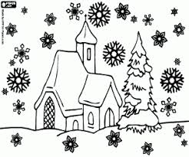

Ρούντολφ το ελαφάκι
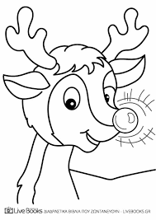
Ρούντολφ το ελαφάκι
Με καρδούλα ταπεινή
Σαν πέφτει το βραδάκι
Έχει μύτη φωτεινή

Οι φίλοι του λαμπιόνι
Τον φωνάζουν και γελούν
Τη μύτη του στο χιόνι
Κρύβει όταν του μιλούν

Όμως μια Πρωτοχρονιά
Είπε ο Άη Βασίλης
Ρούντολφ είσαι εσύ σοφός
Έχεις μέσα σου το φως

Τα ελάφια στο κοπάδι
Χαμηλώσανε τα αφτιά
Τώρα απαλή σαν χάδι
Είναι όλων η ματιά

Από τότε και κάθε καινούρια χρόνια
Του έλκηθρου πρώτος τράβα τα σχοινιά
Ο Ρούντολφ οδηγεί
Τον Άη Βασίλη στη γη

Ρούντολφ το ελαφάκι…
Jingle Bell Rock

Jingle bell, jingle bell, jingle bell rock
Jingle bells swing and jingle bells ring
Snowing and blowing up bushels of fun
Now the jingle hop has begun
Jingle bell, jingle bell, jingle bell rock
Jingle bells chime in jingle bell time
Dancing and prancing in Jingle Bell Square
In the frosty air.
What a bright time, it's the right time
To rock the night away
Jingle bell time is a swell time
To go gliding in a one-horse sleigh
Giddy-up jingle horse, pick up your feet
Jingle around the clock
Mix and a-mingle in the jingling feet
That's the jingle bell,
That's the jingle bell,
That's the jingle bell roc

